***Documentation***

**Title: BSides Prishtina 2023**

**Project description:**

BSides Prishtina 2023 was the second edition of the BSides security conference in Kosovo, aimed at promoting, educating, and raising public awareness about cybersecurity. This one-day event, held at the University of Prishtina, featured lectures from local and international speakers on various cybersecurity topics. The conference was community-driven, volunteer-organized, and aimed to foster collaboration and growth within the information security community in Kosovo and the Western Balkans region. The event targeted students, professionals, and academics in the field of cybersecurity.

**Activities:**Key activities:

* Organizing and hosting lectures and workshops on cybersecurity topics.
* Coordinating with local and international speakers for presentations.
* Setting up the venue at the University of Prishtina, including arranging equipment and materials.
* Managing attendee registration and providing event support throughout the conference.
* Promoting the event through social media, emails, and local channels to increase participation.

**Photos:**

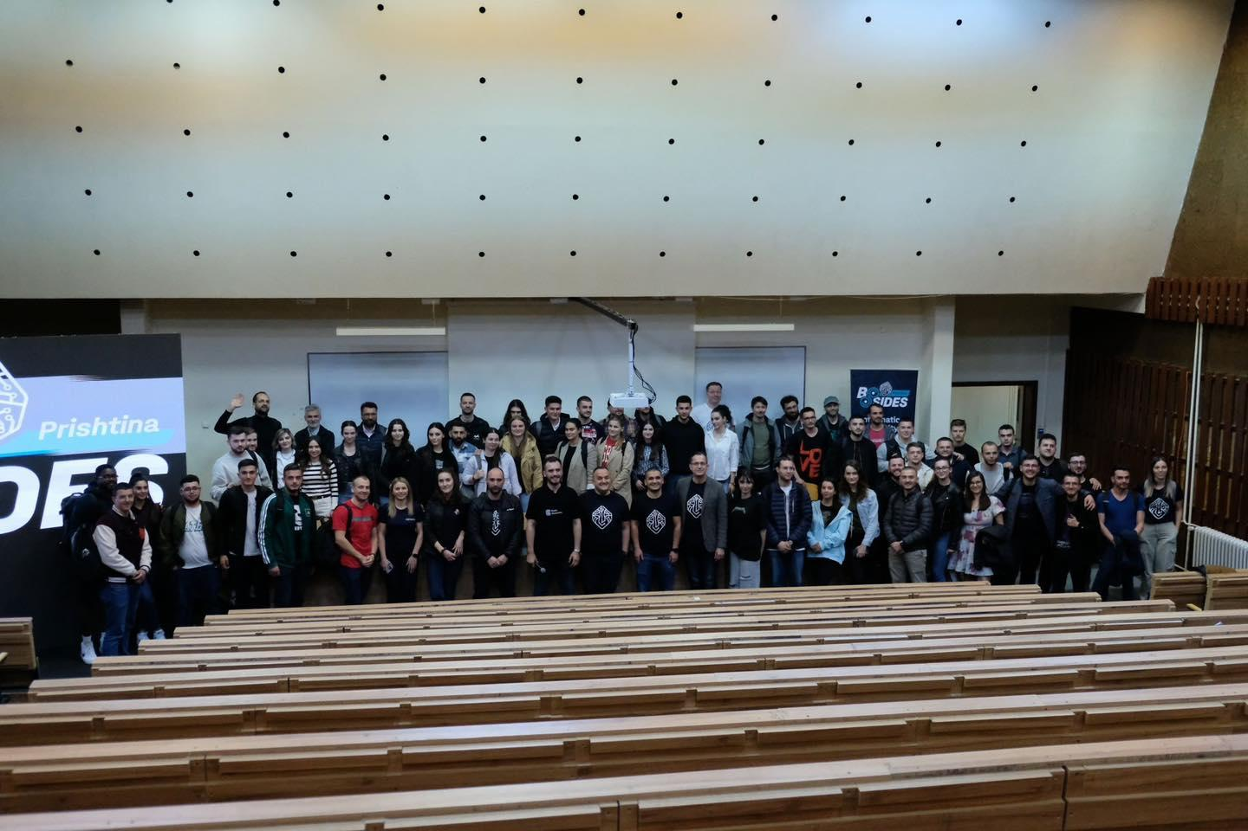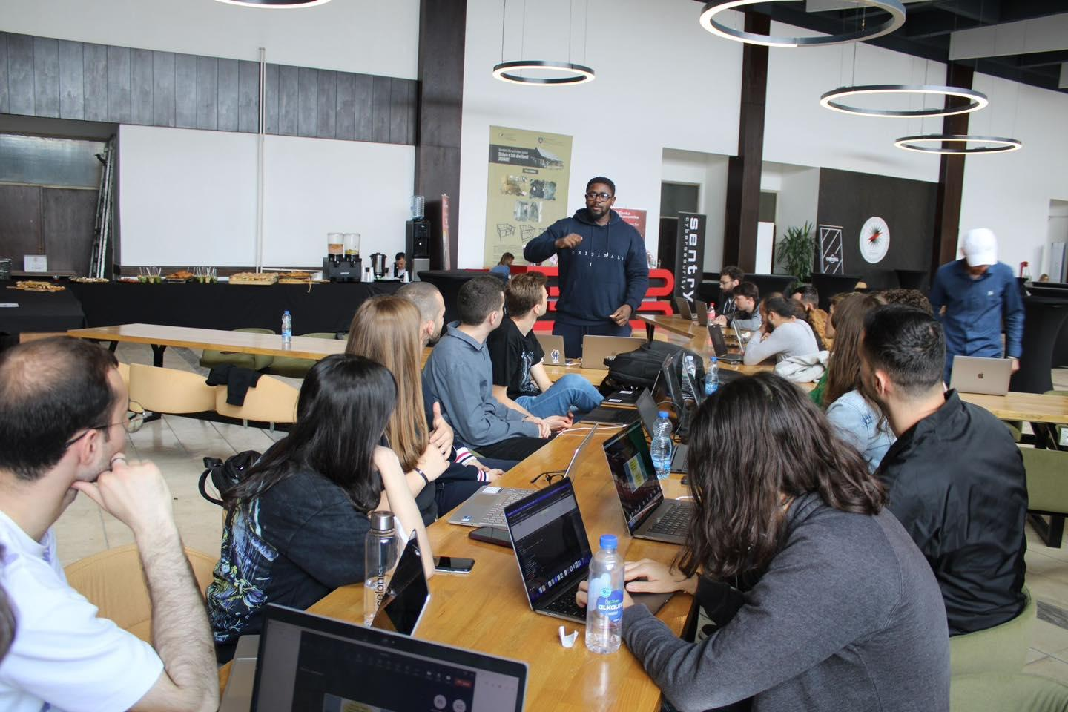

**Beneficiaries:**

Students in Kosovo and the Western Balkans interested in cybersecurity.

Information security professionals and academics seeking to expand their knowledge and network.

Local and international speakers who had an opportunity to engage with the regional community.

**Partners:**

* -

**Budget:  
€8667.89**

**Project duration**:

May 5, 2023 - May 6, 2023

*This document is FLOSSK intellectual property - Do not share without authorization from FLOSSK.*